Experiment 2.2

# Student Name: Rahul Kumar UID: 20BCS7081

**Branch: BE-CSE Section/Group:20BCS_DM-716 B**

# Semester: 6 Date of Performance: 03/04/23

**Subject Name: IOT LAB Subject Code: 20CSP_358**

# Aim:

Interfacing of Arduino with temperature and humidity sensor with real time application.

# Objective:

* + Learn about IoT based simulations.
  + Learning the circuitry.
  + Learning about the sensor.
  + Using the tinker cad.

# Code-Output:

## Hardware Requirement

* + - Arduino Uno

## DH11

* + - Jumper Wire

### About DH11 Sensor:

DHT11 Module features a temperature & humidity sensor complex with a calibrated digital signal output. The exclusive digital-signal-acquisition technique and temperature & humidity sensing technology ensure high reliability and excellent long-term stability. This sensor includes an NTC for temperature measurement and a resistive-type humidity measurement component for humidity measurement. These are connected to a high-performance 8-bit microcontroller, offering excellent quality, fast response, anti-interference ability, and cost-effectiveness.

## Circuit

### DHT11 Module Pinout:

The DHT11 module has a total of 3 pins. In which two are for power and one is for communication. The pinout of a DHT11 Sensor module is as follows:

**DATA :-** Data pin for 1-wire communication.

**GND :-** Ground Connected to Ground pin of the Arduino.

**VCC :-** Provides power for the module, Connect to the 5V pin of the Ardui

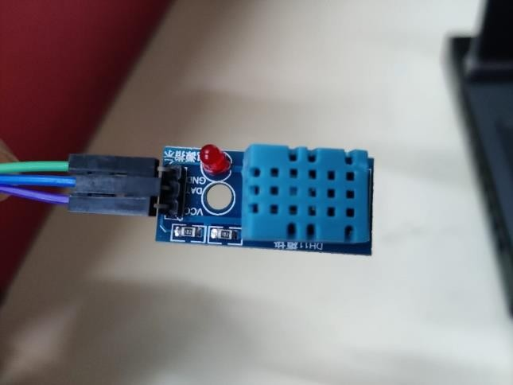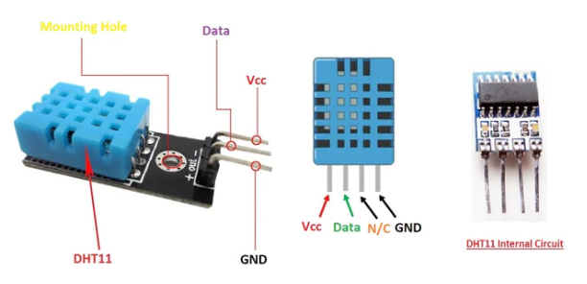

**Code :-**

#include <Adafruit_Sensor.h> #include <DHT.h>

#include <DHT_U.h>

#define DHTTYPE DHT11 // DHT 11 #define DHTPIN 2

DHT_Unified dht(DHTPIN, DHTTYPE); uint32_t delayMS;

void setup() { Serial.begin(9600); dht.begin(); sensor_t sensor;

delayMS = sensor.min_delay / 1000;

}

void loop()

{

sensors_event_t event; dht.temperature().getEvent(&event); Serial.print(F("Temperature: ")); Serial.print(event.temperature); Serial.println(F("°C")); dht.humidity().getEvent(&event); Serial.print(F("Humidity: ")); Serial.print(event.relative_humidity); Serial.println(F("%")); delay(delayMS);

}

### OUTPUT : -

